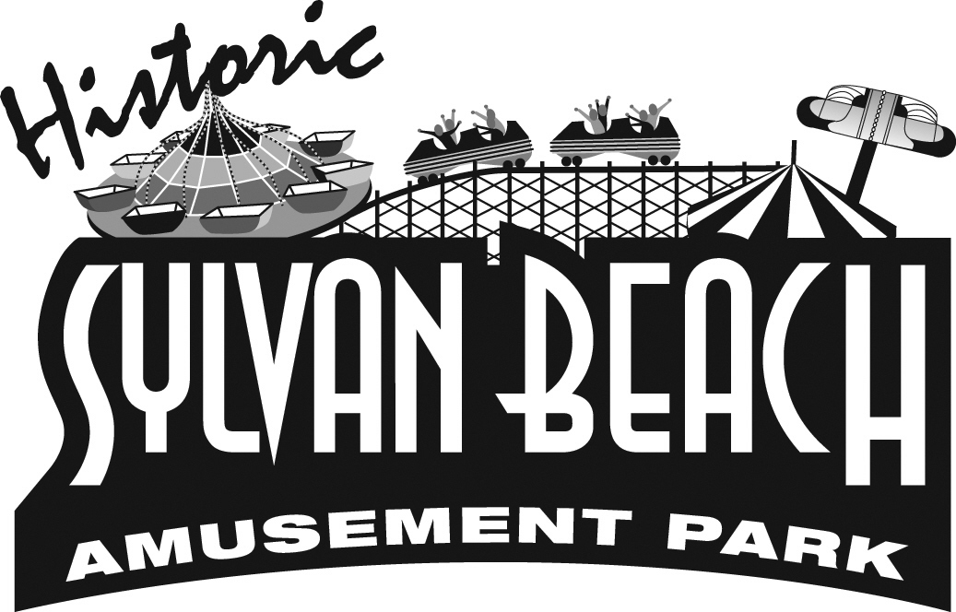
SYLVAN BEACH AMUSEMENT PARK
P.O. Box 763
Sylvan Beach, NY 13157

EMPLOYMENT APPLICATION

DATE: _____________________________________
All qualified applicants will be considered without regard to race, color, religion, sex, national origin, or handicap. All jobs are seasonal and include game attendants, ride operators, food service workers, cashiers, clerks, maintenance, and groundskeepers. Weekend and holiday work is required and hours will vary. * New York state law regulates the age of ride operators – under 18 must include date of birth.
______________________________PERSONAL DATA (PLEASE PRINT)_____________________________

NAME: _____________________________________________________ PHONE:________________________________

MAILING ADDRESS: ________________________________________________________________________________

*DATE OF BIRTH: __________________________ DO YOU HAVE A VALID DRIVER’S LICENSE? ____________

E-MAIL ADDRESS: __________________________________________________________________________________

HAVE YOU EVER BEEN CONVICTED OF ANYTHING OTHER THAN A MINOR TRAFFIC

VIOLATION? _______________ EXPLAIN ______________________________________________________________
_______________________________________EDUCATION_________________________________________
SCHOOL NAME CITY & STATE CURRENT OR MAJOR OR YEAR OF LAST LEVEL SPECIALTY GRADUATION

HIGH 9 10 11 12
COLLEGE
OR TRADE 1 2 3 4

DO YOU HAVE ANY SPECIAL ACTIVITIES DURING OUR SEASON SUCH AS: DRIVER’S EDUCATION, SOCCER, TENNIS, FOOTBAL, FIELD HOCKEY, ETC. PRACTICE, SUMMER LEAGUES, THEATER, COLLEGE ORIENTATION, ETC? IF SO, LIST AND GIVE APPROXIMATE DATES:

DATE YOU CAN START WORK: _________________________ EXPECTED LAST DAY OF WORK: __________________________________

DATE RETURNING TO SCHOOL:____________________ ARE YOU AVAILABLE WEEKENDS WHILE ATTENDING SCHOOL?_______

WHAT POSITIONS WOULD INTEREST YOU? (Circle all that apply) Amusement Park: Rides -Games – Food Service – Retail Sales – Grounds Restaurant: Ice Cream/Busser – Dish Washer – Server – Line Cook – Hostess – Bar Tender – Cocktail Server - Bouncer

_______________________EMPLOYMENT HISTORY AND REFERENCES__________________________

LIST PREVIOUS JOB EXPERIENCE, MOST RECENT FIRST:
NAME OF EMPLOYER ADDRESS TELEPHONE JOB HELD REASON FOR LEAVING

GIVE AT LEAST TWO REFERENCES NOT RELATIVES OR FORMER EMPLOYERS:
NAME ADDRESS TELEPHONE HOW DO YOU KNOW THIS PERSON

MAY WE CHECK YOUR REFERNCES? _______________ YES _________________ NO
__________________________________________________________________________________________
____________________________TELL US A LITTLE ABOUT YOURSELF___________________________

ARE YOU EMPLOYED ELSEWHERE? _________________ WHERE? __________________________________________________________

DO YOU HAVE ANY TIMES OF THE DAY OR WEEK THAT YOU ARE NOT AVAILABLE TO WORK? IF SO, GIVE THOSE

TIMES: ___________________________________________________________________________________________________________________

DO YOU HAVE ANY SPECIAL ABILITIES OR HOBBIES? _____________________________________________________________________

DO YOU HAVE ANY FRIENDS OR RELATIVES WHO HAVE EVER WORKED FOR THE SYLVAN BEACH AMUSEMENT PARK OR

YESTERDAY’S ROYAL? IF SO, NAME, YEAR WORKED, AND JOB HELD ______________________________________________________

__________________________________________________________________________________________________________________________________________

IF UNDER 18, DO YOU HAVE WORKING PAPERS? ___________________________________________________________________________

** IN A BRIEF PARAGRAPH, PLEASE TELL US WHY YOU ARE APPLYING FOR SUMMER EMPLOYMENT WITH US. INCLUDE ANY SPECIAL QUALIFICATIONS YOU HAVE THAT YOU FEEL WOULD MAKE YOU A GREAT EMPLOYEE.

I UNDERSTAND THAT IF I AM OFFERED EMPLOYMENT I AM REQUIRED TO PROVIDE IDENTIFICATION OF UNITED STATES CITIZENSHIP OR PROOF OF ELIGIBILITY TO BE EMPLOYED AS AN ALIEN IN THE UNITED STATES.

IF UNDER 18 YEARS OF AGE, I UNDERSTAND THAT I MUST SUPPLY THE PROPER WORKING PAPERS REQUIRED FOR MY AGE, A LETTER OF ACADEMIC ELIGIBILITY FROM MY SCHOOL, AND PERMISSION FROM A PARENT OR GUARDIAN TO WORK PAST 10 PM ON A SCHOOL NIGHT, IF NECESSARY.

I CERTIFY THAT THE INFORMATION GIVEN ON THIS APPLICATION IS ACCURATE AND COMPLETE. GIVING INCOMPLETE OR FALSE INFORMATION IS A SERIOUS MATTER AND GROUNDS FOR DISMISSAL. I AUTHORIZE SYLVAN BEACH AMUSEMENT PARK AND/OR YEATERDAY’S ROYAL TO CONTACT ALL FORMER EMPLOYERS AND REFERENCES TO FURTHER INQUIRE AS TO ANY INFORMATION GIVEN BY ME ON THIS APPLICATION. IN ACCEPTING EMPLOYMENT I UNDERSTAND I WILL BE ON PROBATION FOR A PERIOD OF TEN (10) WORKING DAYS.

SIGNATURE: _________________________________________________________ DATE: _________________________________

___________________________________FOR INTERVIEWERS USE ONLY__________________________________

DATE OF INTERVIEW: ____________________________________ DATE HIRED: _________________________________________

WORKING PAPERS: Y N G B 0 1 2 3 4 5 POSSIBLE POSITIONS: ___________________________________________

DESCRIPTION OF ANY LIMITATIONS OR ALLERGIES (that would affect type of position offered):

EYE CONTACT: ( ) Good ( ) Poor
GROOMING: ( ) Somewhat careless ( ) Ordinary ( ) Better than average ( ) Outstanding
SELF-EXPRESSION: ( ) Unresponsive ( ) Hesitant ( ) Spoke Fluently ( ) Excellent Communication
MOTIVATION: ( ) Seemed to lack motivation ( ) Good/Average ( ) Enthusiastic & Interested
OVERALL IMPRESSION: ( ) Poor ( ) Acceptable ( ) Good ( ) Excellent

COMMENTS:

